**JUNAID GIRKAR**

**60004190057**

**TE Comps A4**

**LAB EXPERIMENT NO. 01**

**Aim: Perform data Pre-processing task using Weka data mining tool**

**Theory:**

WEKA - an open source software provides tools for data preprocessing, implementation of several Machine Learning algorithms, and visualization tools so that you can develop machine learning techniques and apply them to real-world data mining problems

**Tasks performed through Weka:**

Preprocessing:

Classification:

Clustering:

Association Rule:

Select Attributes:

Visualization:

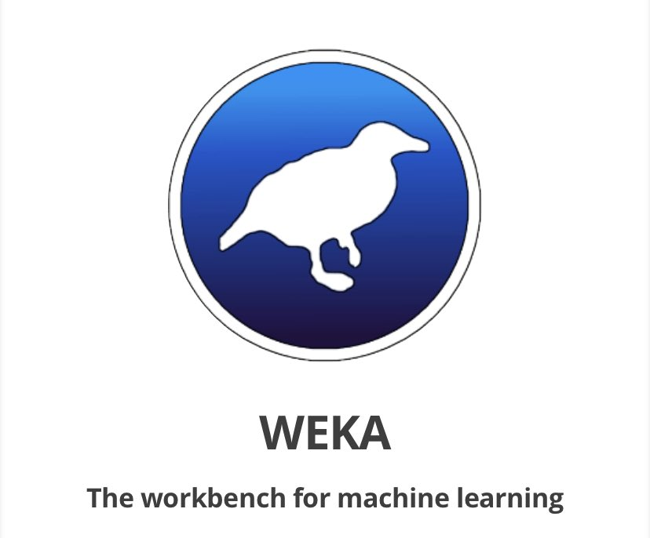

**Preprocessing activities to be observed in Weka:**

**1. Visualization:** Visualize scatter plot for all the attributes from dataset selected from Weka. Determine correlation if any using these plots for different datasets

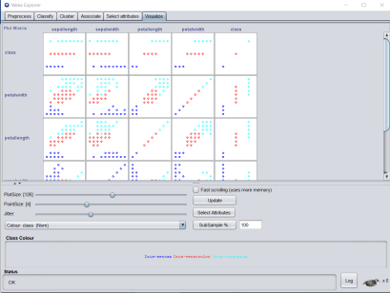

Upon observing the scatter plot in the visualize section, we can observe certain correlations within

the attributes. Some of them have been listed below

a. Petal length vs Sepal length: Positive correlation

b. Petal length vs Petal width: Positive correlation

c. Petal width vs Sepa length: Positive correlation

**2. Select Attributes:** Apply suitable feature selection filter like GainRatio etc to choose relevant attributes from the list of attributes. Observe the ranks / priority provided by the filter.

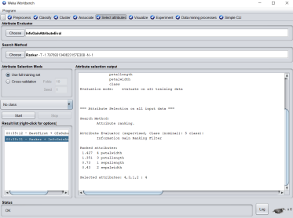

We apply the attribute Ranker using the InfoGainAttributeEval method in the Select Attribute tab to determine which attribute holds the most importance while forming clusters/classification. The results show that Petal Length is the most important attribute among the others

**3. Preprocessing:**

**a. Visualize All:** Select this button to visualize histograms of all attributes.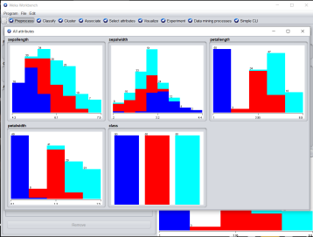

**b. Filter:** Choose Discretization under Unsupervised and Supervised methods. Observe the discretization and the outliers.

**SUPERVISED DISCRETIZE FILTERING**

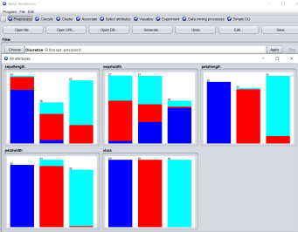

**UNSUPERVISED DISCRETIZE FILTERING**

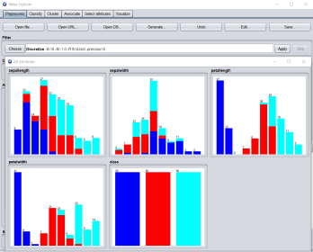

We can observe the discretization of the Sepal Length variable. The number of bins reduces from 6 to 3.

**c. IQR:** Observe the IQR values for a selected attribute. Observe the outlier and extreme values

**OUTLIER**

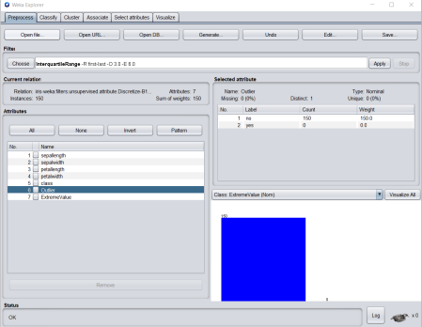

**EXTREME VALUE**

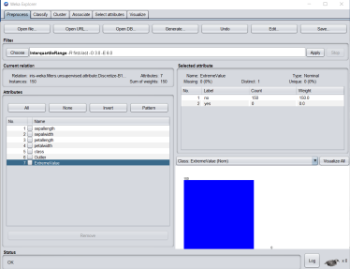

Upon visualizing all the variables, we can view the outliers present per variable and can remove the extreme values.

**d. Removethevalue:** Remove instances with outlier values and show the screenshots of the dataset before and after the removal.

BEFORE DELETION:

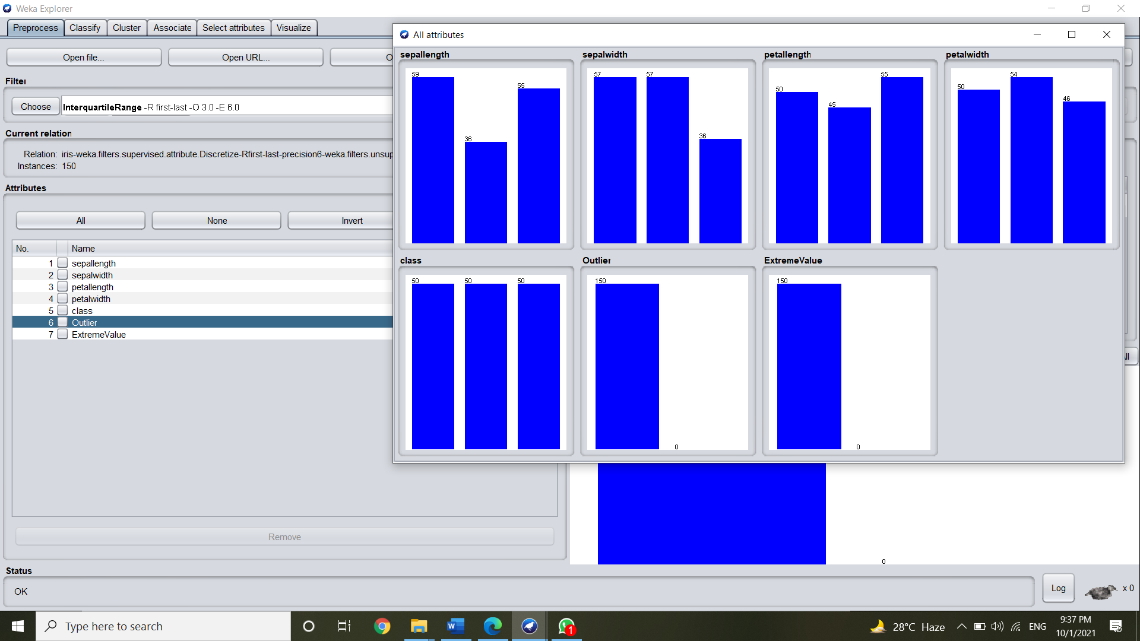

AFTER DELETION:

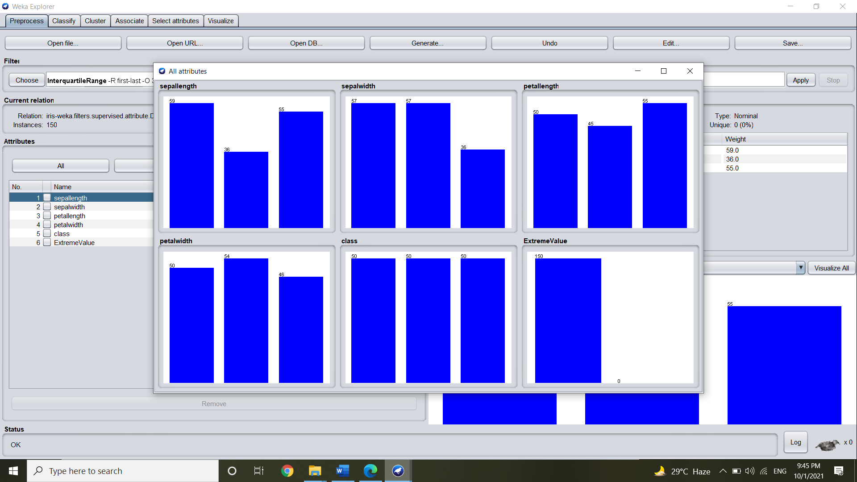

**4. Classification:** Perform NB, kNN and DT/rule based classification

The **classify** tab is for training and evaluating the performance of different machine learning algorithms on your classification or regression problem. Algorithms are divided up into groups, results are kept in a result list and summarized in the main Classifier output.

Here we are applying the Naive Bayers Classifier.

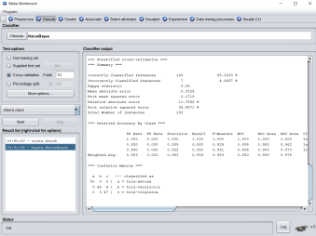

**5. Clustering:** Perform kmeans, hierarchical clustering and explain the output The **cluster** tab is for training and evaluating the performance of different unsupervised clustering algorithms on your unlabeled dataset. Like the Classify tab, algorithms are divided into groups, results are kept in a result list and summarized in the main Clusterer output.

Here we are applying SimpleKmeans Clustering algorithm with 3 classes

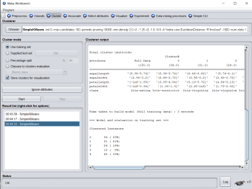

**6. Association rule mining:** Perform apriori algo and show the rules created. The **associate** tab is for automatically finding associations in a dataset. The techniques are often used for market basket analysis type data mining problems and require data where all attributes are categorical.

Here we are using the supermarket dataset and we configure the Apriori algorithm to perform market-basket analysis.

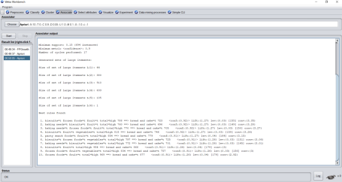

**CONCLUSION**:

We learnt about the Weka tool and how to do data analysis with it. We used 2 different databases: Iris petals and Supermarket.

We tried both the supervised and unsupervised learning algorithms. We can easily visualize with charts how the data transforms when we filter it using different algorithms.

We also used the select attribute to find out which attribute is ranked best for classification. We implemented different clustering and classification algorithms.

In the second database i.e., the supermarket one, we implemented the associate function where we configured the Apriori algorithm to perform market-basket analysis.